Code Smells Identified
Shotgun Surgery
In this package, the class /jabref/src/main/java/org/jabref/migrations/PreferancesMigrations.java has multiple strings with the same value. If there is a change of one string, it is inconvinient to search all the strings with the same value and change.
Possible Solution:
If possible, create constants, enumerators to store all the strings with the same value and/or functions to adapt the current solution.
Examples: Image 1 and 2.
Feature Envy
In the previous class has functions that focus on manipulating data of other classe rather than itself.
Possible Solution:
Reduce the amount of method calls by moving the current methods implementations pr creating new methods inside each class.
Examples:
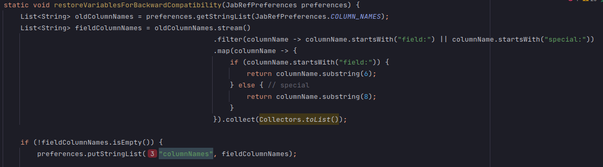
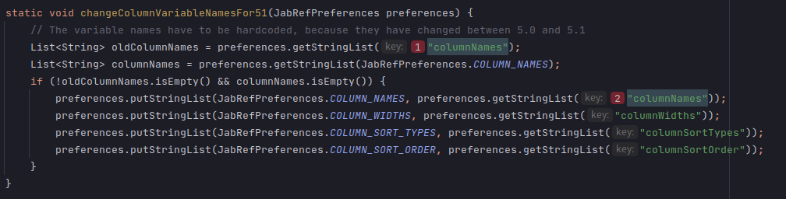

Innapropriate Intimacy
In the class /jabref/src/main/java/org/jabref/migrations/MergeReviewIntoCommentMigration.java has publics methods that calls and has access to private parts, such as variables and functions, of other classes.
Possible Solution:
Create new private functions that gets all the variables needed to the current method.
Example:
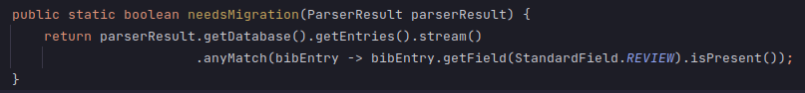

Cognitive Complexity
/**
* Determine whether there starts a special char at pos (e.g., oe, AE). Return it as string.
* If nothing found, return Optional.empty()
*
* <p>
* Also used by BibtexPurify
*
* @param c the current "String"
* @param pos the position
* @return the special LaTeX character or null
*/
public static Optional<String> findSpecialChar(char[] c, int pos) {
if ((pos + 1) < c.length) {
if ((c[pos] == 'o') && (c[pos + 1] == 'e')) {
return Optional.of("oe");
}
if ((c[pos] == 'O') && (c[pos + 1] == 'E')) {
return Optional.of("OE");
}
if ((c[pos] == 'a') && (c[pos + 1] == 'e')) {
return Optional.of("ae");
}
if ((c[pos] == 'A') && (c[pos + 1] == 'E')) {
return Optional.of("AE");
}
if ((c[pos] == 's') && (c[pos + 1] == 's')) {
return Optional.of("ss");
}
if ((c[pos] == 'A') && (c[pos + 1] == 'A')) {
return Optional.of("AA");
}
if ((c[pos] == 'a') && (c[pos + 1] == 'a')) {
return Optional.of("aa");
}
}
if ("ijoOlL".indexOf(c[pos]) >= 0) {
return Optional.of(String.valueOf(c[pos]));
}
return Optional.empty();
}
Located in jabref/src/main/java/org/jabref/logic/bst/BibtexCaseChanger.java
Problem: The cognitive complexity (Measurement of how hard to understand the control flow of a method is) present in this method is too high (value of 23 passing the default value of 15)
Refactor proposal:
Change type of c from “char[]” to “String[]”, which would represent all two character segments made from the “current string”, and use the String method “contains()” or “equalsIgnoreCase()” to check if each two character segment follows one of the mentioned patterns. If so, return that segment, otherwise return null if we reached the end of our string.

Excess Comments
// Comments from bibtex.web:
// sp_ptr := str_start[pop_lit1];
int i = 0;
// sp_end := str_start[pop_lit1+1];
int n = s.length();
// sp_brace_level := 0;
int braceLevel = 0;
// while (sp_ptr < sp_end) do begin
while (i < n) {
// incr(sp_ptr);
i++;
// if (str_pool[sp_ptr-1] = left_brace) then
// begin
if (c[i - 1] == '{') {
// incr(sp_brace_level);
braceLevel++;
// if ((sp_brace_level = 1) and (sp_ptr < sp_end)) then
if ((braceLevel == 1) && (i < n)) {
// if (str_pool[sp_ptr] = backslash) then
// begin
if (c[i] == '\\') {
// incr(sp_ptr); {skip over the |backslash|}
i++; // skip over backslash
// while ((sp_ptr < sp_end) and (sp_brace_level
// > 0)) do begin
while ((i < n) && (braceLevel > 0)) {
// if (str_pool[sp_ptr] = right_brace) then
if (c[i] == '}') {
// decr(sp_brace_level)
braceLevel--;
} else if (c[i] == '{') {
// incr(sp_brace_level);
braceLevel++;
}
// incr(sp_ptr);
i++;
// end;
}
// incr(num_text_chars);
result++;
// end;
}
// end
}
// else if (str_pool[sp_ptr-1] = right_brace) then
// begin
} else if (c[i - 1] == '}') {
// if (sp_brace_level > 0) then
if (braceLevel > 0) {
// decr(sp_brace_level);
braceLevel--;
// end
}
} else { // else
// incr(num_text_chars);
result++;
}
}
stack.push(result);
Located in jabref/src/main/java/org/jabref/logic/bst/VM.java
Problem: Multiple sections of code commented out, affecting the code’s readibility and understanding
Refactor proposal: Remove them from the source code and replace with comments that explain what logic is happening in this section. An overall comment explaining the first ever if and else should be enough to understand the code.

Long Parameter List
public CitationKeyPatternPreferences(boolean shouldAvoidOverwriteCiteKey,
boolean shouldWarnBeforeOverwriteCiteKey,
boolean shouldGenerateCiteKeysBeforeSaving,
KeySuffix keySuffix,
String keyPatternRegex,
String keyPatternReplacement,
String unwantedCharacters,
GlobalCitationKeyPattern keyPattern,
Character keywordDelimiter) {
this.shouldAvoidOverwriteCiteKey = shouldAvoidOverwriteCiteKey;
this.shouldWarnBeforeOverwriteCiteKey = shouldWarnBeforeOverwriteCiteKey;
this.shouldGenerateCiteKeysBeforeSaving = shouldGenerateCiteKeysBeforeSaving;
this.keySuffix = keySuffix;
this.keyPatternRegex = keyPatternRegex;
this.keyPatternReplacement = keyPatternReplacement;
this.unwantedCharacters = unwantedCharacters;
this.keyPattern = keyPattern;
this.keywordDelimiter = keywordDelimiter;
}
Located in jabref/src/main/java/org/jabref/logic/citationkeypattern/CitationKeyPatternPreferences.java

Problem: Constructor with too many parameters ( value of 9 parameters surpassing the default 7 allowed)

Refactor Proposal: Make a data class to either include all the booleans or all the Strings (or maybe both) to reduce the amount of global variables and parameters required for this method.
3 parameters for keySuffix, GlobalCitationKeyPattern and Character;
2 (5 parameters total with two data classes containing 3 variables each) if using a data class for all booleans and another for the Strings;
4 (7 parameters total with a data class containing 3 variables) if using only for booleans or strings;
1 (4 parameters total with a data class containing 6 variables) if using the data class for all booleans and strings.)
Long Class
java/org/jabref/gui/preview/CopyCitationAction.java: line 94-174
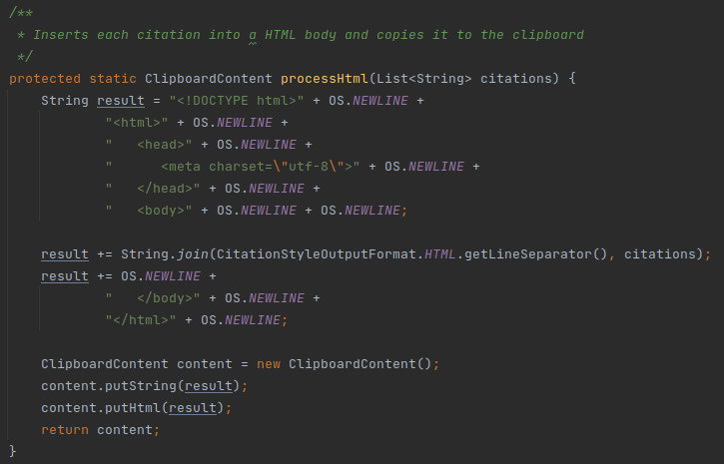
Problem: This class is doing more than it should. There should be an uniform way of formating citations to the various formats.

Refactoring Proposal: Extract the citation process methods on this class and place it in a suiting class the citationstyle package.

Switch Statement
java/org/jabref/gui/EntryTypeView.java: line 210-316
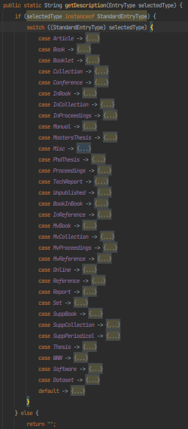
Problem: This switch statement iterates through all the values in the Enum. If we wanted to add a new type of entry, or remove one, we would need to refractor 2 classes.
Refractoring Proposal: Extract this method and add description as an instance variable in the StandardEntryType Enum.

Lack of constants
java/org/jabref/gui/fieldeditors/LinkedFileViewModel.java: lines 208, 226, 260, 312
Problem: The String “File not found” and “Could not find file ‘%0’.” can be found repeated throughout this class. This increases chances of creating inconsistencies.

Refractoring Proposal: Creating class constants for these Strings.

Long Parameter List

java/org/jabref/preferences/GuiPreferences.java: line 28-35
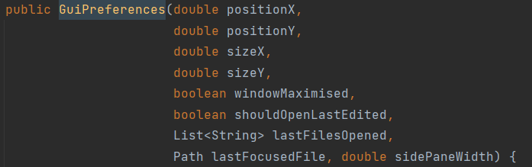
Problem: The constructor of this class has too many parameters (9 parameters, which is greater than the 7 authorized).

Refactoring Proposal: Create a new class which deals with the positionX, positionY, sizeX and sizeY and this code smell should be solved.

Inappropriate Naming
java/org/jabref/preferences/JabRefPreferences.java: line 146 and 413

Problem: Names should not differ only by capitalization.

Refractoring Proposal: change private Language language to private Language currLanguage.

Cognitive Complexity
java/org/jabref/preferences/JabRefPreferences.java: lines 747-789
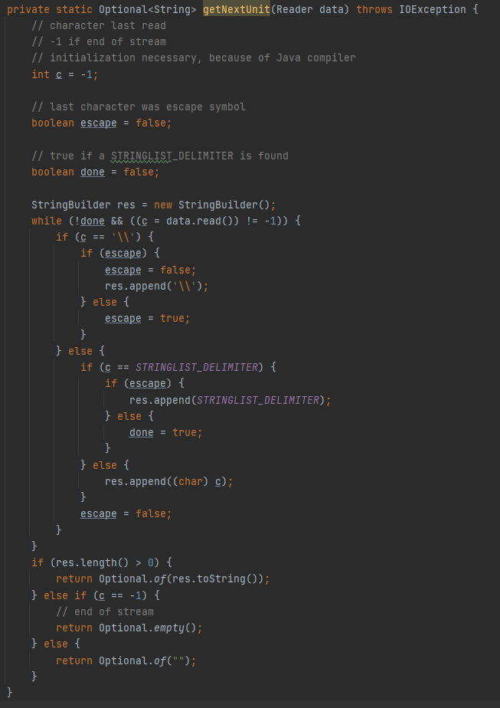
Problem: Method is too complex thus hard to maintain.

Refractoring Proposal: More comments should be added to better explain this method or it should be broken into smaller methods.

Long Method
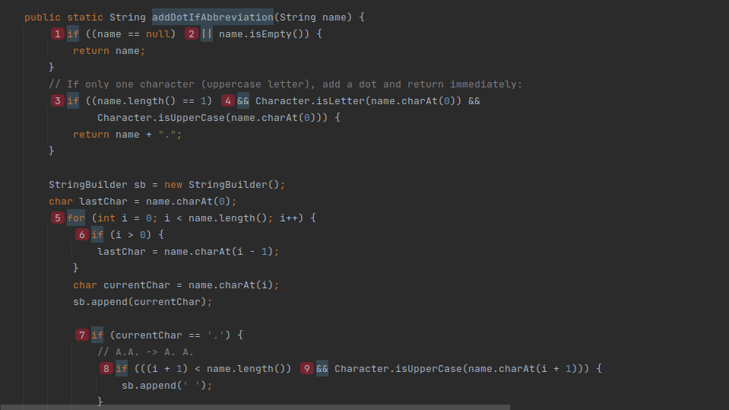
Located at src/java/org/jabref/model/author.java line 39 the method addDotIfAbbreviation
Problem: it’s 82 lines long and has a cognitive complexity of 41 (way above the default value of 15)
Refactor Proposal:
Split into several methods to reduce complexity and length. The inner code on the outer for (lines 52 to 117) could be moved to a new method that takes the input chars (currentChar and lastChar) and the String Builder. The same could then be done for the inner for loop (lines 99 to 116)
Long Class
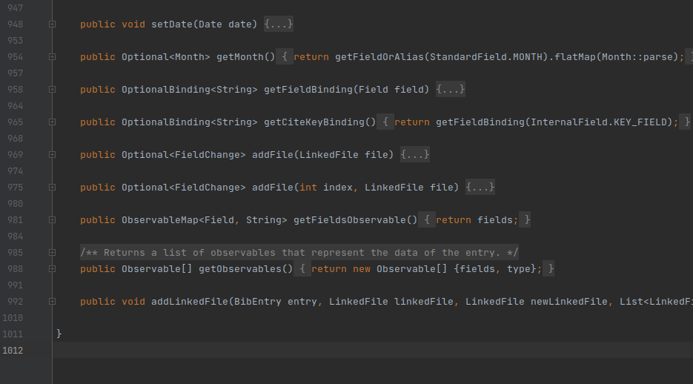
Located at src/java/org/jabref/model/entry/BibEntry.java
Problem: Class spans over too many lines, over 1000, and provides too many methods
Refactor proposal:
Create a new class BibEntryFields that stores the fields for the BibEntry and provides all related functionality, allowing to remove responsibility and methods from BibEntry.java

Duplicated Code
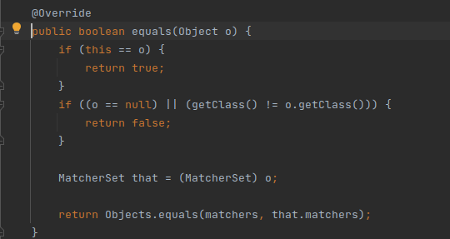
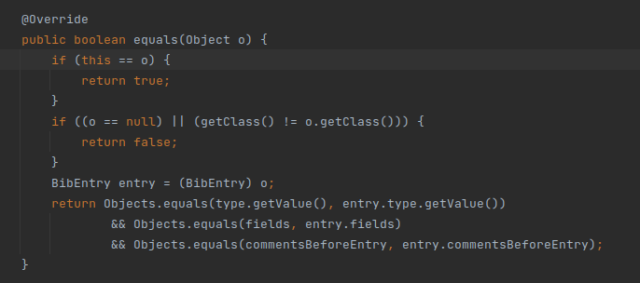
Location: src/main/java/org/jabref/model/search/matchers/MatcherSet.java, src/java/org/jabref/model/entry/BibEntry.java and several other places
Problem: This segment of the equals method has similar duplicates many times across the code. This could be an issue if another generic case needs to be considered which would alter the result or allow a faster matching.
Refactor Proposal:
Extract the common part of the method to a static method and pass the non common part of the verification as a lambda

